**VISVESVARAYA TECHNOLOGICAL UNIVERSITY**

**Jnana Sangama, Santhibastawad Road, Machhe**

**Belagavi - 590018, Karnataka, India**



**WEB DEVELOPEMENT LAB MINI-PROJECT REPORT**

**ON**

*“***E-learning System***”*

*Submitted in the partial fulfilment of the requirements for the completion of 7th Semester web developement Laboratory with Mini Project[17CSL77] course of*

**BACHELOR OF ENGINEERING**

**IN**

**INFORMATION SCIENCE AND ENGINEERING**

**For the Academic Year 2020-2021**

**Submitted by**

**SPURTHY M** **1JS17IS074**

**TRISHALA KUMARI** **1JS17IS082**

**Under the Guidance of**

**Dr. Sowmya K.N**

**Assistant Professors**

**Dept. of ISE, JSSATE**



**2020-2021**

**DEPARTMENT OF INFORMATION SCIENCE AND ENGINEERING**

**JSS ACADEMY OF TECHNICAL EDUCATION**

**JSS Campus, Dr.Vishnuvardhan Road, Bengaluru-560060**

**JSS MAHAVIDYAPEETHA, MYSURU**

**JSS ACADEMY OF TECHNICAL EDUCATION**

**JSS Campus, Dr.Vishnuvardhan Road, Bengaluru-560060**

**DEPARTMENT OF INFORMATION SCIENCE & ENGINEERING**



**CERTIFICATE**

This is to certify that the File Structures mini Project entitled **“E-learning system”**is a work carried out by **Trishala kumari[1JS17IS082], Spurthy M[1JS17IS074]** of VII semester Information Science and Engineering from JSS Academy of Technical Education during the academic year 2020-2021.

|  |  |  |
| --- | --- | --- |
| **Signature of the Guide** |  | **Signature of the Hod** |
| **Dr. Sowmya K.N** |  | **Dr. Dayananda P** |
| **Assistant Professor** |  | Head of the Dept. |
| Dept. of ISE |  | Dept. of ISE |
| JSSATE, Bengaluru  Name of the examiner  1.  2. |  | JSSATE, Bengaluru  Signature with date |

**ACKNOWLEDGEMENT**

The satisfaction and euphoria that accompany the successful completion of any task would be incomplete without the mention of the people who made it possible. So with gratitude, we acknowledge all those whose guidance and encouragement crowned my effort with success.

First and foremost we would like to thank his **Holiness Jagadguru Sri Shivarathri Deshikendra Mahaswamiji** and **Dr.Mrityunjaya V Latte**, Principal, JSSATE, Bangalore for providing an opportunity to carry out the Project Workas a part of our curriculum in the partial fulfilment of the degree course.

We express our sincere gratitude for our beloved Head of the department, **Dr. Dayananda P**, for his co-operation and encouragement at all the moments of our approach.

It is our pleasant duty to place on record our deepest sense of gratitude to our respected guide  **Dr. Sowmya K.N , Asst. Professor and Mr. Anil BC Asst. Professor** for the constant encouragement, valuable help and assistance in every possible way.

We would like to thank all ISE Department Teachers, non teaching staff and Library staff for providing us with their valuable guidance and for being there at all stages of our work.

**Spurthy M[1JS17IS074]**

**Trishala kumari[1JS17IS082]**

**Abstract**

In the era of digital world where technology covers every human needs. Education is also digitalized now a day. Specially in the era of covid-19 pandemic when every schools and colleges shut down due to the lockdown. Learning process never stopped due to e-learning system.

E-learning is basically the transfer of skills and information that is computer and network-enabled. Web-based learning, computer-based learning, interactive education opportunities and digital collaboration are included in E-learning technologies and processes. Over the Internet, intranet/extranet, audio or videotape, satellite TV, and CD-ROM, content is provided. It can be instructor-led or self-paced and includes media in the form of text, image, animation, streaming video and audio.

The aim of the e-learning system is to automate the current manual system, by means of computerized equipment and full-fledged computer applications, to meet their requirements, so that their precious data/information can be stored for a longer period of time with easy access and manipulation.

E-learning System encompasses freedom, flexibility and the power to break conventions of traditional learning methods. Here E stands for Extended, Enhanced, Electronic, Efficient, Effective learning. The learning experience is successfully conveyed to the learner with a friendly presence.

**TABLE OF CONTENTS PAGE NO.**

**1. INTRODUCTION 1**

**2. LITERATURE SURVEY 4**

**3. SYSTEM ANALYSIS 8**

**4. SYSTEM DESIGN 10**

**5. SYSTEM IMPLEMENTATION 15**

**6. TESTING 26**

**7. SNAPSHOTS AND RESULT 33**

**8. CONCLUSION AND FUTURE ENHANCEMENT 40**

**9. REFERENCES 41**

**CHAPTER 1**

**INTRODUCTION**

E-learning is an education via the internet, network, or standalone computer. E-learning is essentially the network- enabled convey of skills and knowledge. E-learning refers to using electronic applications and processes to find out . E-learning includes all sorts of electronically supported learning and teaching. The information and communication systems, whether networked learning or not, serve as specific media to implement the learning process. This often involves both out-of-classroom and in-classroom educational experiences via technology, whilst advances continue in regard to devices and curriculum.

E-learning is the computer and network-enabled transfer of skills and knowledge. E-learning applications and processes include Web-based learning, computer-based learning, virtual education opportunities and digital collaboration. That is to mention E-learning systems contain both Learning Management System and Course management system. It can be self-pace or instructor-led and includes media within the sort of text, image, animation, streaming video and audio. It is commonly thought that new technologies can make an enormous difference in education. In young ages especially, children can use the large interactivity of latest media, and develop their skills, knowledge, and perception of the planet , under their parents' monitoring, of course.

Many proponents of e-learning believe that everybody must be equipped with basic knowledge in technology, also as use it as a medium to succeed in a specific goal and aim. In the 21st century, we've moved from the economic Age through the knowledge Age and now to the Knowledge Age. Knowledge and its efficient management constitute the key to success and survival for organizations within the highly dynamic and competitive world of today. Efficient acquisition, storage, transfer, retrieval, application, and visualization of data often distinguish successful organizations from unsuccessful ones. The ability to get , assimilate, and apply the proper knowledge effectively will become a key skill within the next century. Learning is that the key to achieving our full potential.

Our survival in the 21first century as individuals, organizations, and nations will 2 depend upon our capacity to learn and the application of what we learn to our daily lives. E-learning has the potential to rework how and when employees learn. Learning will become more integrated with work and can use shorter, more modular, just-in-time delivery systems. By leveraging workplace technologies, e-learning is bridging the gap between learning and work. Workers can integrate learning into work more effectively because they use an equivalent tools and technology for learning as they use for work. Both employers and employees recognize that e-learning will diminish the narrowing gap between work and residential , and between work and learning. E-learning is an choice to any organization looking to enhance the skills and capacity of its employees. With the rapid change altogether types of working environments, especially medical and healthcare environments, there's a continuing need to rapidly train and retrain people in new technologies, products, and services found within the environment. There is also a constant and unrelenting need for the appropriate management and leveraging of the knowledge base so that it is readily available and accessible to all stakeholders within the workplace environment

**1.1 Objectives**

* The purpose of this project is to develop a back-end application for e-learning applications and queries using graphical user interface and web development concepts.
* It allows for flexible data format and deliver of its data so that each analysis application can receive only the information it needs and in the format required.
* It makes the teaching and learning easy through online mode.
* To perform task analysis: Determine the tasks to be taught, identify subtasks and other elements involved, and identify the knowledge, skills, and attitudes required to complete the tasks efficiently and effectively.
* To reduce learning costs: because there are no papers, no delays, and no travel expenses
* The project is divided into 3 modules – student, faculty and admin. The objective of the modules are as follows

**Student Module**

* Preview announcements
* Download assignment materials and upload the answer back
* Answer the given quizzes
* View Grades
* View Classmates

**Faculty Module**

* Post announcement to this class
* Upload assignment materials
* Create an automated quizzes
* Display grades from the quiz
* Add and remove students from the class

**Admin Module**

* Create a class for the teacher and add students to the class
* Manage Student Accounts
* Manage Faculty Accounts
* Manage Subjects
* Manage Admin Users
* Track every users and activity history
* Post announcement to all classes

**1.2 Scope**

The Scope of this project is very high as students are leaning more towards the online education. This is a platform to help students get more educated. With the E-Learning, the concept of learning has differed from the old times. This e-learning platform is widely increased as the each individual contains a smart phone with high speed internet through which, each can access the courses on the websites in minutes. The teaching and learning process gets easy through this system. Teachers can easily upload assignments, notes and provide quizzes to all students in their class. It will be very efficient System for admin as both students and teachers are in same platform.

**CHAPTER 2**

**LITERATURE SURVEY**

**Web**

Web consists of billions of clients and server connected through wires and wireless networks. The web clients make requests to web server. The web server receives the request, finds the resources and returns the response to the client. When a server answers a request, it usually sends some type of content to the client. The client uses web browser to send request to the server. The server often sends response to the browser with a set of instructions written in HyperText Markup Language(HTML). All browsers know how to display HTML page to the client.

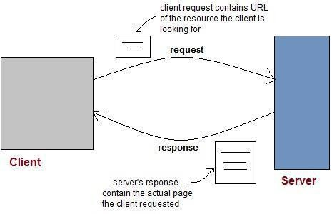

Figure 1.1 HTML—Client-Server communication

**HTML**

Hypertext Markup Language (HTML) is the standard markup language for creating web pages and web applications. HTML describes the structure of Web pages using markup. HTML elements are the building blocks of HTML pages.HTML elements are represented by tags.HTML tags label pieces of content such as "heading", "paragraph", "table", and so on. Browsers do not display the HTML tags, but use them to render the content of the page.

**PHP**

PHP is a general-purpose server-side scripting language originally designed for Web development to produce dynamic Web pages. It is one of the first developed server- side scripting languages to be embedded into an HTML source document, rather than calling an external file to process data. Ultimately, the code is interpreted by a Web server with a PHP processor module which generates the resulting Web page. It also has evolved to include a command-line interface capability and can be used in standalone graphical applications.

PHP can be deployed on most Web servers and also as a standalone shell on almost every operating system and platform free of charge. A competitor to Microsoft's Active Server Pages (ASP) server-side script engine and similar languages, PHP is installed on more than 20 million Web sites and 1 million Web servers.

In this application, PHP is used for interacting the webpage with database. Through PHP, the user can meet the server through the HTML page. Using PHP, we can store and retrieve the information from the database using the PHP commands.

**JavaScript**

JavaScript (sometimes abbreviated JS) is a prototype-based scripting language that is dynamic, weakly typed, general purpose programming language and has first-class functions. It is a multi-paradigm language, supporting object-oriented, imperative, and functional programming styles.

JavaScript was formalized in the ECMA Script language standard and is primarily used in the form of client-side JavaScript, implemented as part of a Web browser in order to provide enhanced user interfaces and dynamic websites. This enables programmatic access to computational objects within a host environment. JavaScript's use in applications outside Web pages for example in PDF documents, site-specific browsers, and desktop widgets is also significant.

In this application, JavaScript is used for validation purpose like text box validation, email validation, phone number validation. JavaScript is the good tool for validating the web- applications.

Server Side JavaScript

Meanwhile, Netscape also introduced the language for server-side scripting in Netscape Enterprise Server, first released in December, 1994.

**XML**

Extensible Markup Language (XML) is a markup language that defines a set of rules for encoding documents in a format that is both human-readable and machine- readable. It is defined in the XML 1.0 Specification produced by the W3C, and several other related specifications, all gratis open standards.

The design goals of XML emphasize simplicity, generality, and usability over the Internet. It is a textual data format with strong support via Unicode for the languages of the world. Although the design of XML focuses on documents, it is widely used for the representation of arbitrary data structures, for example in web services.

Many application programming interfaces (APIs) have been developed for software developers to use to process XML data, and several schema systems exist to aid in the definition of XML-based languages. As of 2009, hundreds of XML-based languages have been developed, including RSS, Atom, SOAP, and XHTML.

XML-based formats have become the default for many office-productivity tools, including Microsoft Office (Open Office) OpenOffice.org and LibreOffice (Open Document),and Apple's iWork. XML has also been employed as the base language for communication protocols, such as XMPP.

**MySQL**

MySQL ("My S-Q-L", officially "My Sequel") is the world's most used relational database management system (RDBMS) that runs as a server providing multi-user access to a number of databases. It is named after developer Michael Widenius daughter, my. The SQL phrase stands for Structured Query Language.

The MySQL development project has made its source code available under the terms of the GNU General Public License, as well as under a variety of proprietary agreements. MySQL was owned and sponsored by a single for-profit firm, the Swedish company MySQL AB, now owned by Oracle Corporation.

The projects that require a full featured database management system often use MySQL. For commercial use, several paid editions are available, and offeradditional functionality. Applications which use MySQL databases include: TYPO3, Joomla, WordPress, phpBB, Drupal and other software built on the LAMP /XAMPP software stack.

MySQL is also used in many high-profile, large-scale World Wide Web products, including Wikipedia, Google (though not for searches), Facebook, and Twitter.

Uses of MySQL

MySQL is a popular choice of database for use in web applications, and is a central component of the widely used LAMP open source web application software stack LAMP is an acronym for "Linux, Apache, MySQL, Perl/PHP/Python".

MySQL is an open source database management system and is used in some of the most frequently visited websites on the Internet, including Flickr, Nokia.com, YouTube and as previously mentioned, Wikipedia, Google, Facebook and Twitter.

**CHAPTER 3**

**SYSTEM ANALYSIS**

This project is aimed to build a web application for online learning system and helps to manage information about various activities involved in e-learning system.

As the name specifies E-learning web application project helps to learn online, web application built on e-learning database avoids manual work and makes the information more ease of access and secure, which is an added advantage for people who want to access the information directly. This web application will be compatible compared to the existing system with more GUI friendly and secure.

Project is implemented with all latest web based tools and technologies like WAMP/XAMPP Server.

## Resource requirement

#### 3.1.1 Software Requirements

Software used in the project are as follows

* Front End tools: HTML, JavaScript, JQuery, CSS, PHP
* Back End tools: MYSQL database
* Browser that supports HTML and JavaScript
* IIS or apache server
* WAMP/XAMPP Server

#### 3.1.2 Hardware Requirements

Hardware used in the project are as follows

* CPU: Pentium processor and above
* RAM: 4 GB
* HDD: 40 GB

This project is implemented using XAMP Software, XAMP Software is for Windows platform.

**About WAMP SOFTWARE**

Stands for "Windows, Apache, MySQL, and PHP." WAMP is a variation of LAMP for Windows systems and is often installed as a software bundle (Apache, MySQL, and PHP). It is often used for web development and internal testing, but may also be used to serve live websites.

The most important part of the WAMP package is Apache (or "Apache HTTP Server") which is used run the web server within Windows. By running a local Apache web server on a Windows machine, a web developer can test webpages in a web browser without publishing them live on the Internet.

WAMP also includes MySQL and PHP, which are two of the most common technologies used for creating dynamic websites. MySQL is a high-speed database, while PHP is a scripting language that can be used to access data from the database. By installing these two components locally, a developer can build and test a dynamic website before publishing it to a public web server.

While Apache, MySQL, and PHP are open source components that can be installed individually, they are usually installed together. One popular package is called "Wamp Server," which provides a user-friendly way to install and configure the "AMP" components on Windows.

**CHAPTER 4**

**SYSTEM DESIGN**

# 4.1 INTRODUCTION

System is a collection of an interrelated components that works together to achieve a purpose. System analysis is referred to the systematic examination or detailed study of a system in order to identify problems of the system, and using the information gathered in the analysis stage to recommend improvements or solution to the system.

System design is an abstract representation of a system component and their relationship and which describe the aggregated functionality and performance of the system. System design is also the overall plan or blueprint for how to obtain answer to the question being asked. The design specifies which of the various type of approach.

Systems design is the process or art of defining the architecture, components modules, interfaces, and data for a system to satisfy specified requirements. One could see it as the application of systems theory to product development.

This Project is implemented using PHP, CSS and HTML which is proven to be a very efficient tool in the field of programming. It is done under Windows7,Window10, MAC platform. PHP is used to implement the entire code. Interface to the program is provided with the help of MySQL Database.

### 4.2 ER DIAGRAM

An entity–relationship model or the ER Diagram describes inter-related things of interest in a specific domain of knowledge. An ER model is composed of entity types and specifies relationships that can exist between instances of those entity types

In software engineering an ER model is commonly formed to represent things that a business needs to remember in order to perform business processes. Consequently, the ER model becomes an abstract data model that defines a data or information structure that can be implemented in a database, typically a relational database.

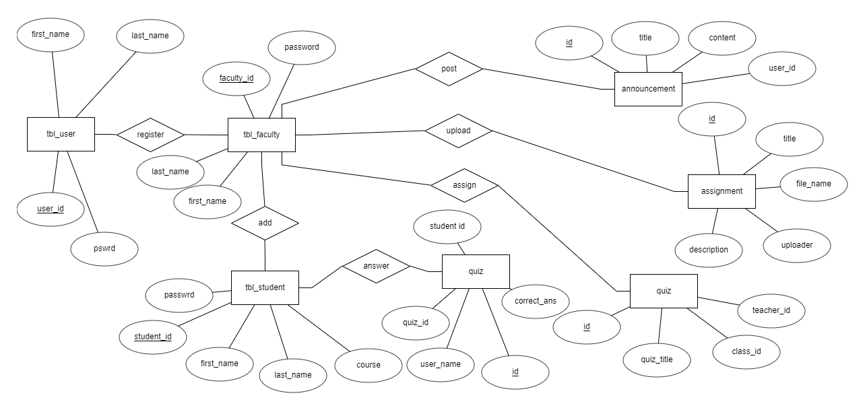

Figure 4.1 ER diagram

* 1. **USE CASE DIAGRAM**

The use case model for any system consists of "use cases". Use cases representϖ different ways In which the system can be used by the user. A simple way to find all the use case of a system is to ask the questions "What the user can do using the system?" The use cases partition the system behaviour into transactions such that each transaction performs some useful action from the users' point of view. The purpose of the use case to define a piece of coherent behaviour without revealing the internal structure of the system. An use case typically represents a sequence of interaction between the user and the system. These interactions consists of one main line sequence is represent the normal interaction between the user and the system. The use case model is an important analysis and design artefact (task).Use cases can be represented by drawing a use case diagram and writing an accompany text elaborating the drawing. In the use case diagram each use case is represented by an ellipse with the name ofϖ use case written inside the ellipse. All the ellipses of the system are enclosed with in a rectangle which represents the system boundary. The name of the system being module appears inside the rectangle. The different users of the system are represented by using stick person icon. The stick person icon is normally referred to as an Actor. The line connecting the actor and the use cases is called the communication relationship. When a stick person icon represents an external system it is annotated by the stereo system>>.

The use case diagram of admin,student,teachers are depicted below:

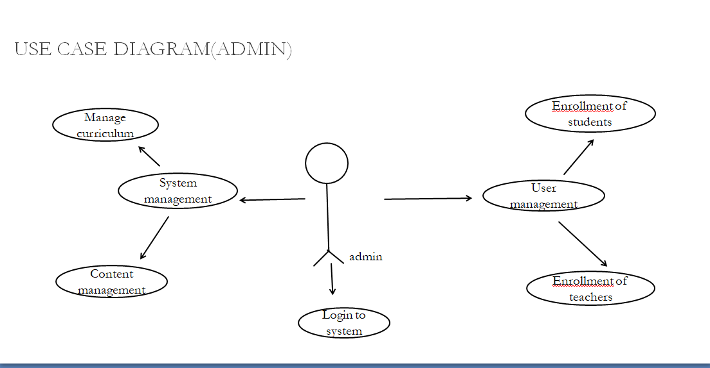

Figure 4.1 use case diagram-admin

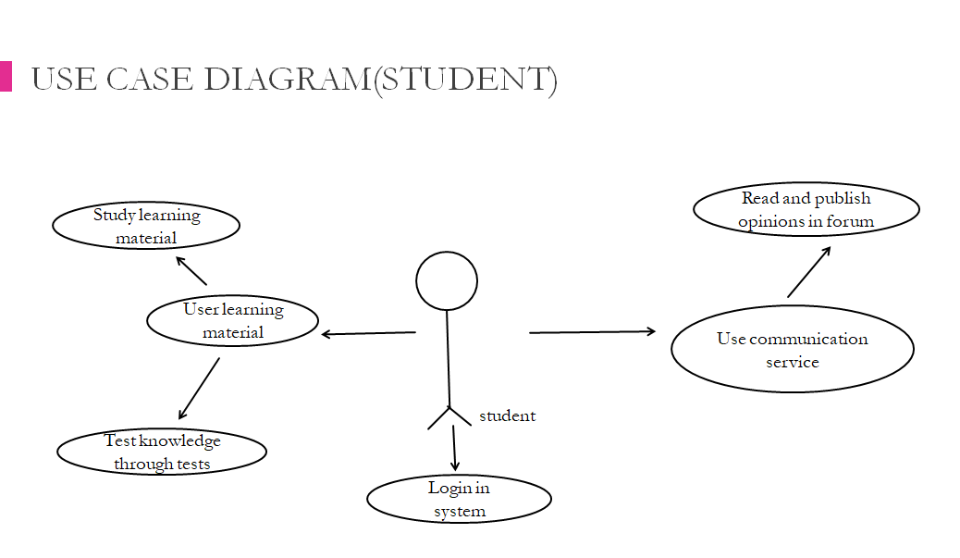

Figure 4.2 use case diagram-student

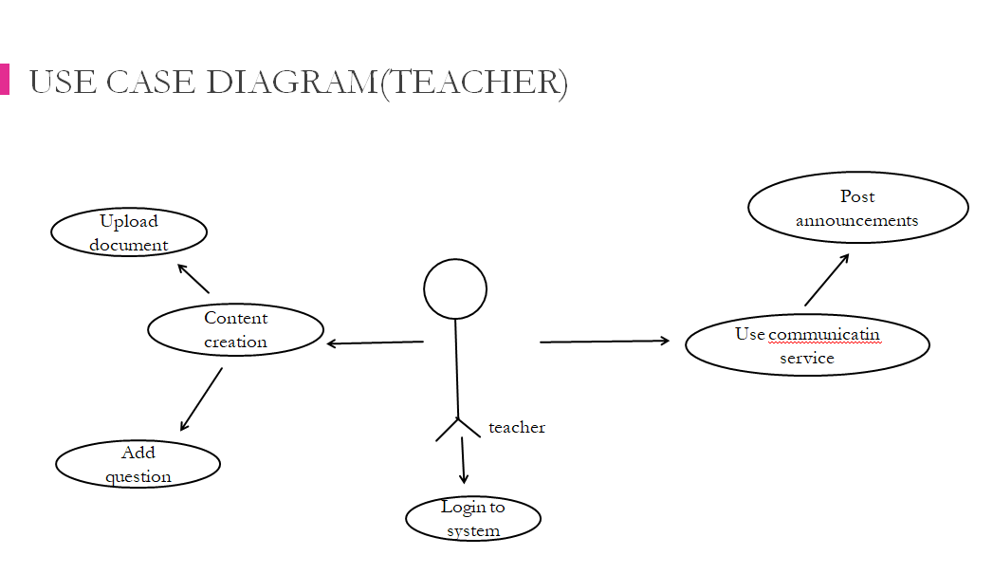

Figure 4.3 use case diagram-teachers

* 1. **DATA FLOW DIAGRAM**

A data-flow diagram (DFD) is a graphical representation of the "flow" of data through an DFDs can also be used for the of processing (structured design). A data flow diagram (DFD) is a significant modeling technique for analyzing and construct ng information processes. DFD literally means an illustration that explains the course or movement of information in a process. DFD illustrates this flow of Information in a process based on the inputs and outputs. A DFD can be referred to as a Process Model. The data flow diagram is a graphical description of a system's data and how to Process transform the data is known as Data Flow Diagram (DFD). Unlike details flow chart, DFDs don't supply detail descriptions of modules that graphically describe a system's data and how the data interact with the system. Data flow diagram number of symbols and the following symbols are of by DeMarco.

The dataflow diagram of our system is depicted below:

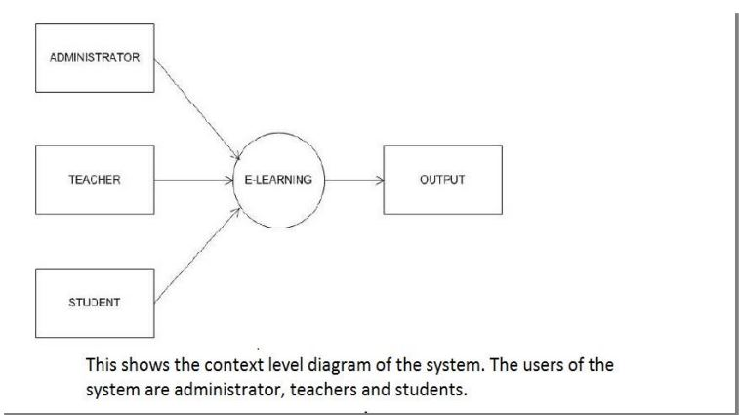

Figure 4.4 Data flow diagram

* 1. **WIREFRAME DIAGRAMS**

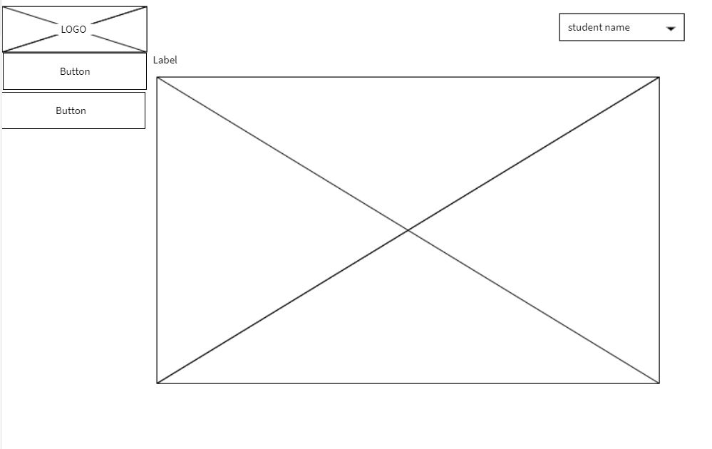

Figure 4.5 wireframe-student

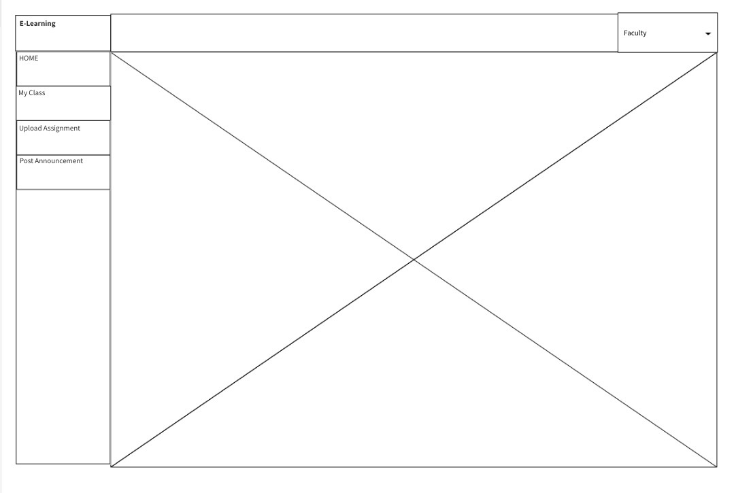

Figure 4.6 wireframe-faculty

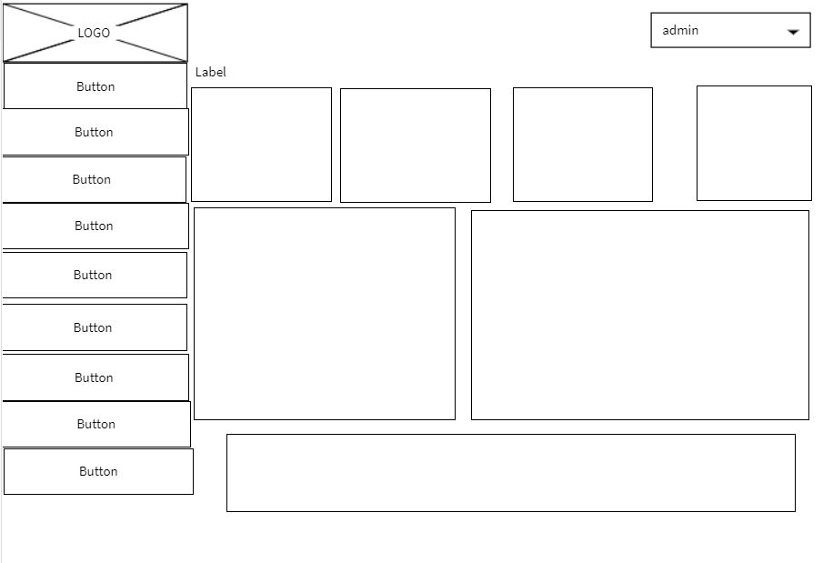

Figure 4.7 wireframe-admin

**CHAPTER 5**

**SYSTEM IMPLEMENTATION**

In our proposed system design, there are 3 entities: An Admin, teacher and student. It has a Student Module that will help the students save time to use and answer the materials that provided by the teachers. Teacher Module, which will benefit the most, because it will keep their classes organized, share material instantly, and creates automated quizzes and generate grades. Admin module will have access to all the features of the system.It provides a fast, safe and a reliable system.

Based on the above requirements, the functional requirements for each entity can be listed as:

**Student Module**

* Sign-up/sign-in
* Preview announcements
* Download assignment materials and upload the answer back
* Answer the given quizzes
* View Grades
* View Classmates

**Faculty Module**

* Sign-up/sign-in
* Post announcement to this class
* Upload assignment materials
* Create an automated quizzes
* Display grades from the quiz
* Add and remove students from the class

**Admin Module**

* Sign-up/sign-in
* Create a class for the teacher and add students to the class
* Manage Student Accounts
* Manage Faculty Accounts
* Manage Subjects
* Manage Admin Users
* Track every users and activity history
* Post announcement to all classes

The brief descriptions of the above functional requirements have been discussed below.

**Home page:**

This page shows the login or registration option for teachers, students and admin.

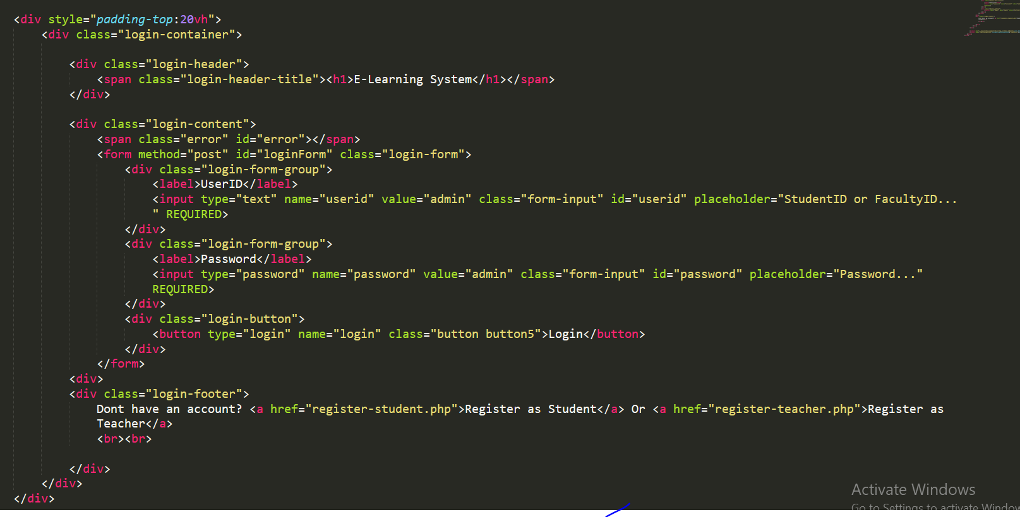

**Student registration**

Student can register by providing important details and name of course.

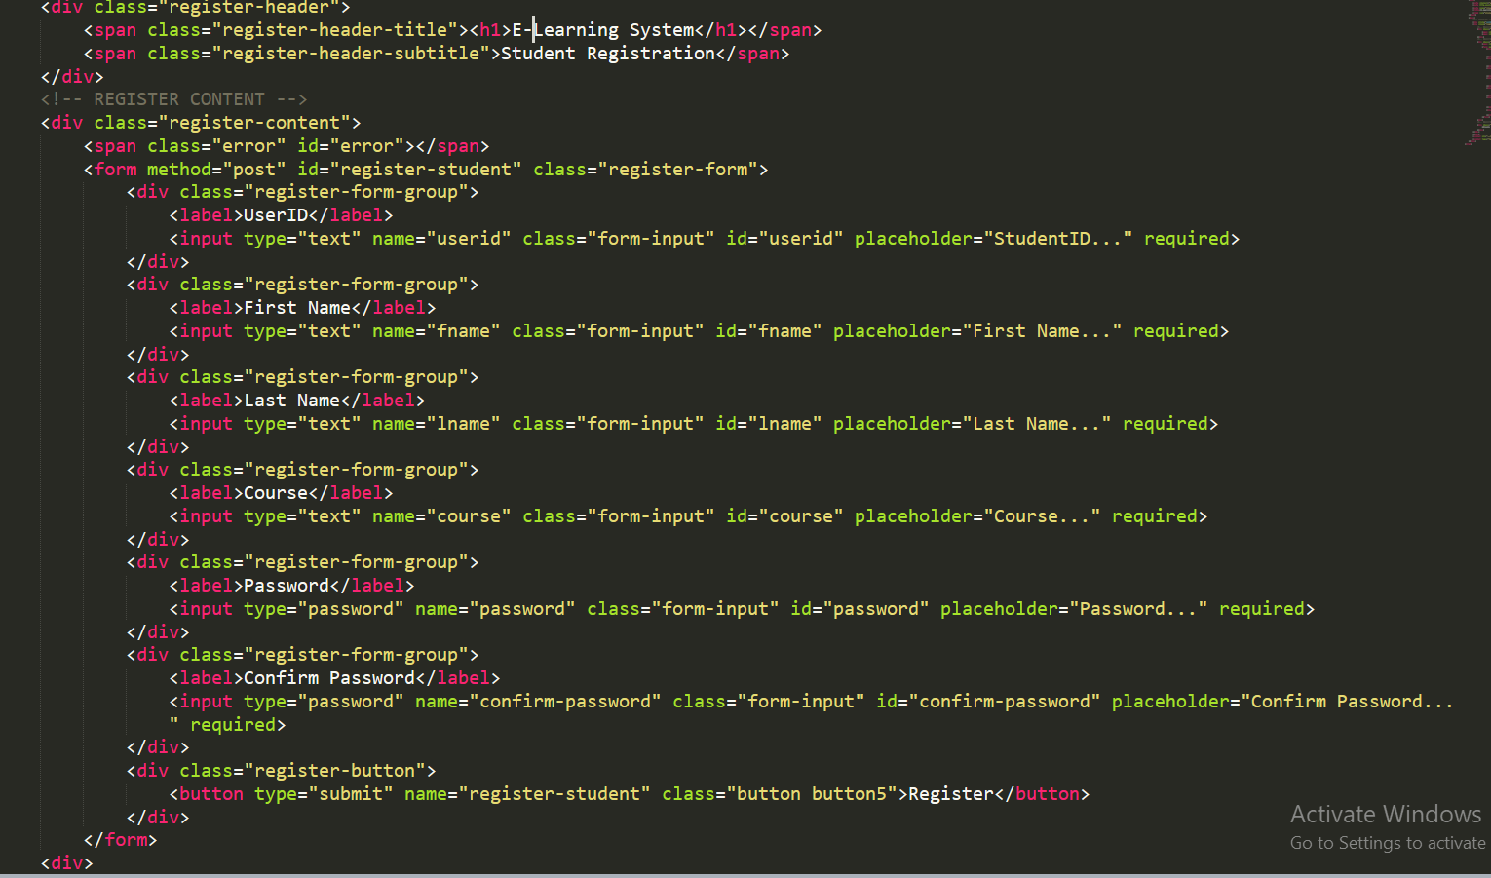

**Teacher registration**

Teacher can register by providing important details and password.

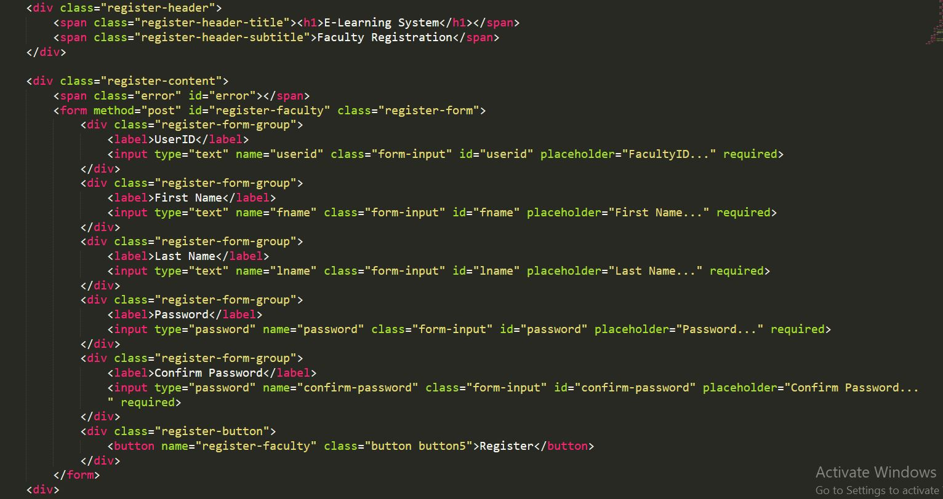

**Admin module:**

Admin can modify class details, register teacher, register student, modify school year, check reports and activity logs.

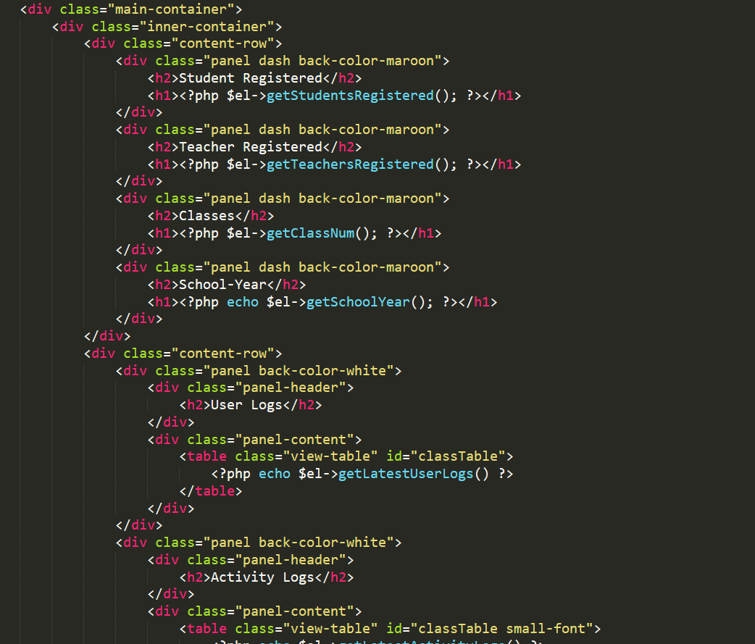

**Create class**

Class code of class can be created by selecting subject,teacher and school year .

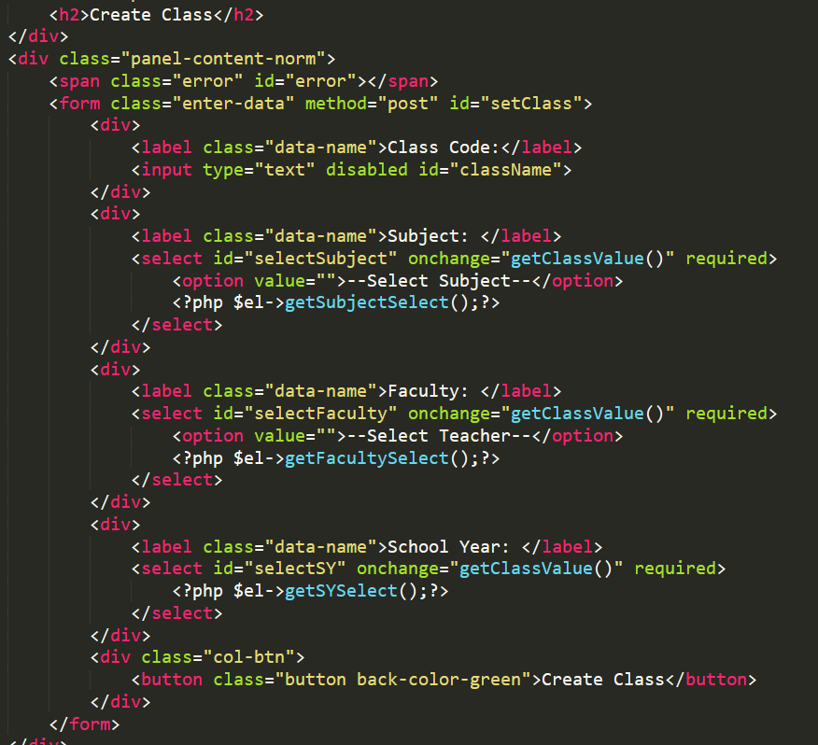

**Announcements:** Admin can post any new announcement to the system.

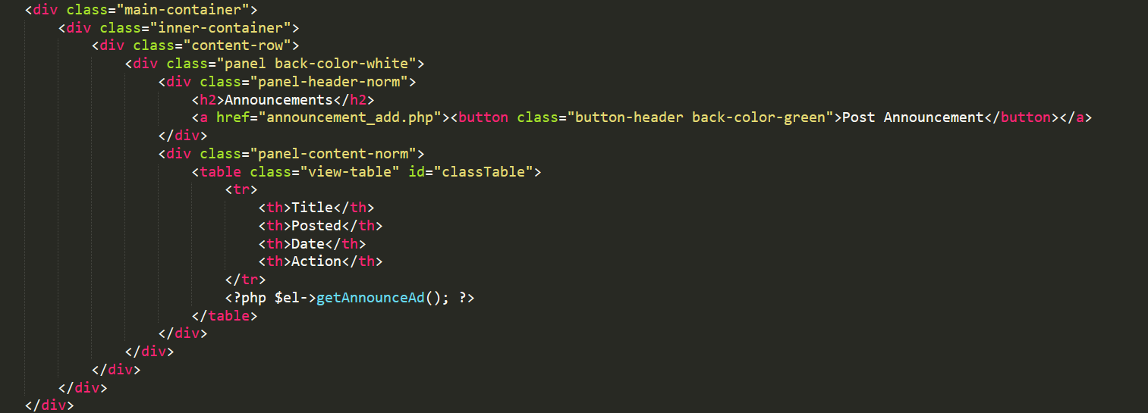

**Add Faculty:** Admin can add and see list of new teachers.

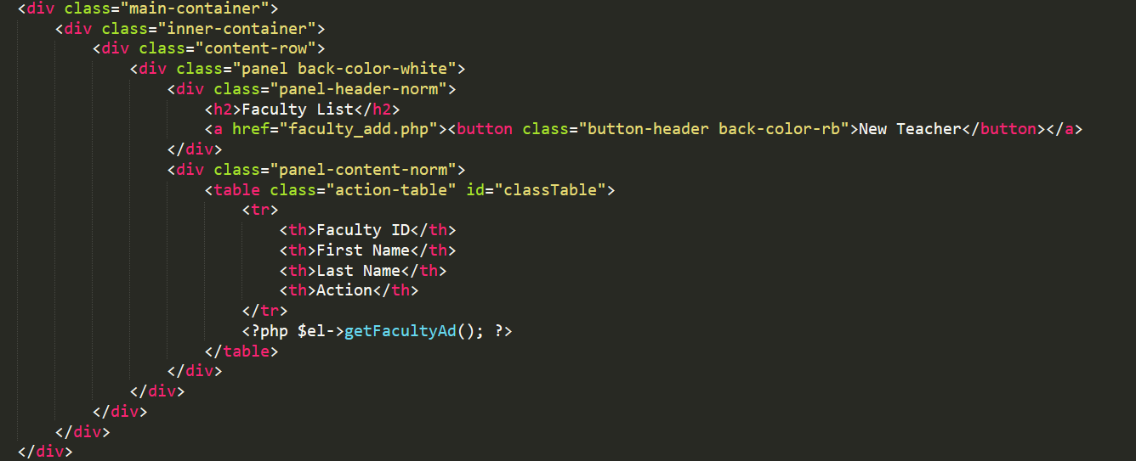

**Report:**  Admin can see reports and activity of users.

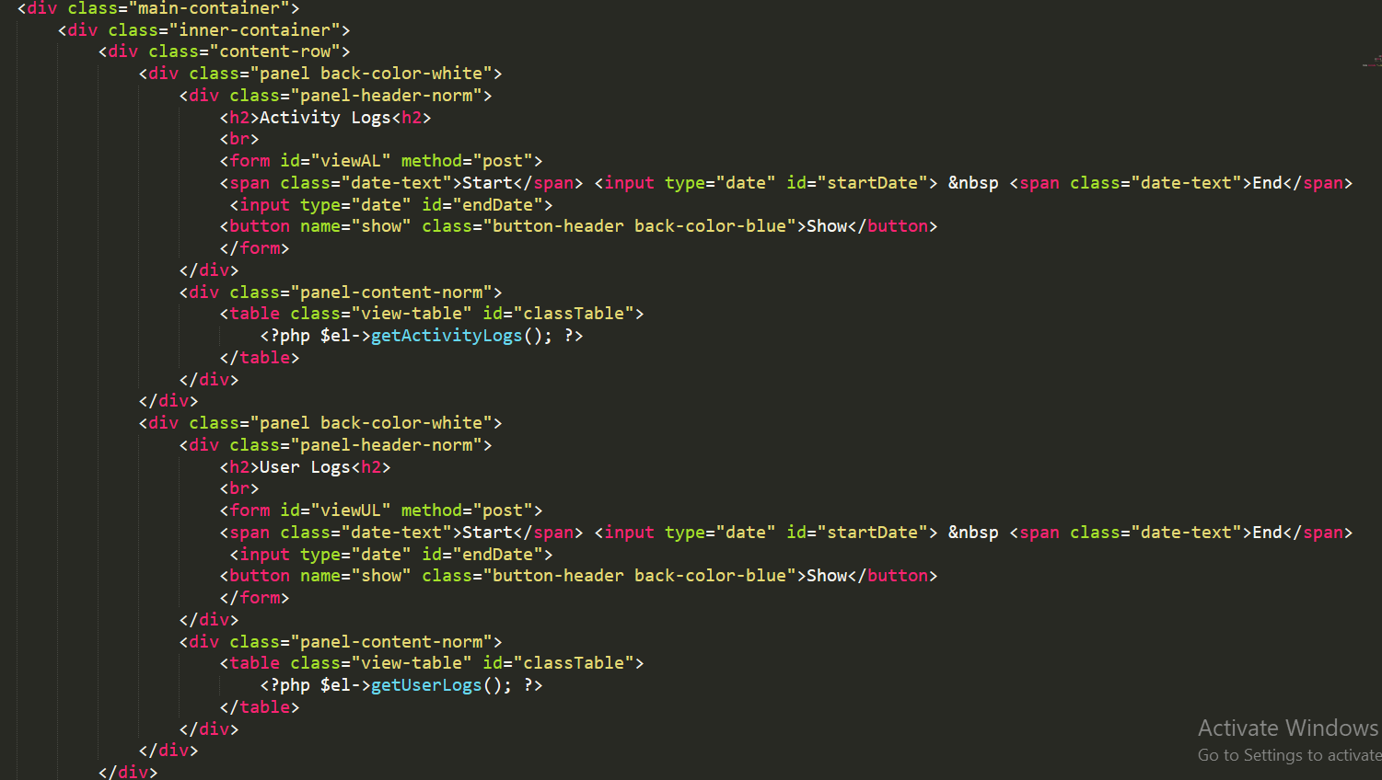

**School year:** Admin can modify academic year.

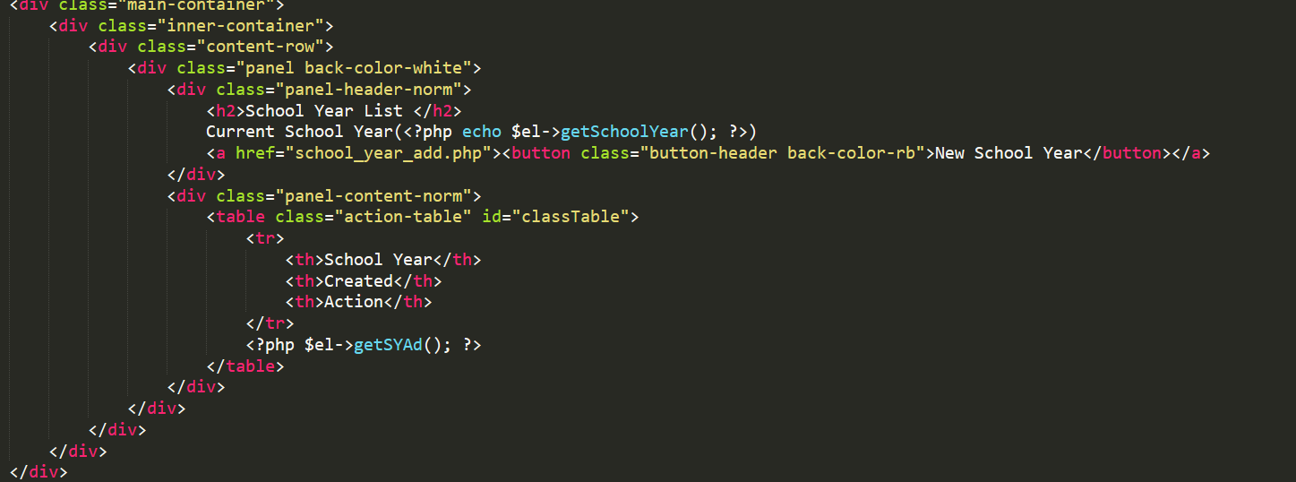

**Register Student:** Admin can add and remove students.

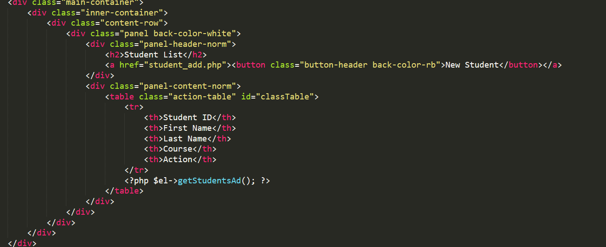

**Subject:** Admin can add subject by giving subject details.

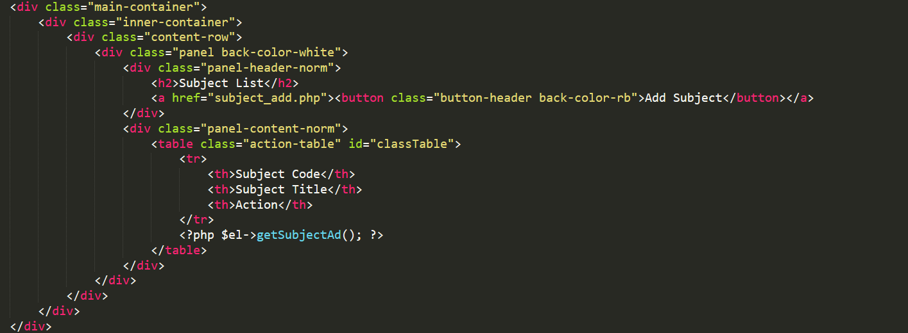

**Faculty module**

**Add announcements:**Teacher can post announcement for classes.

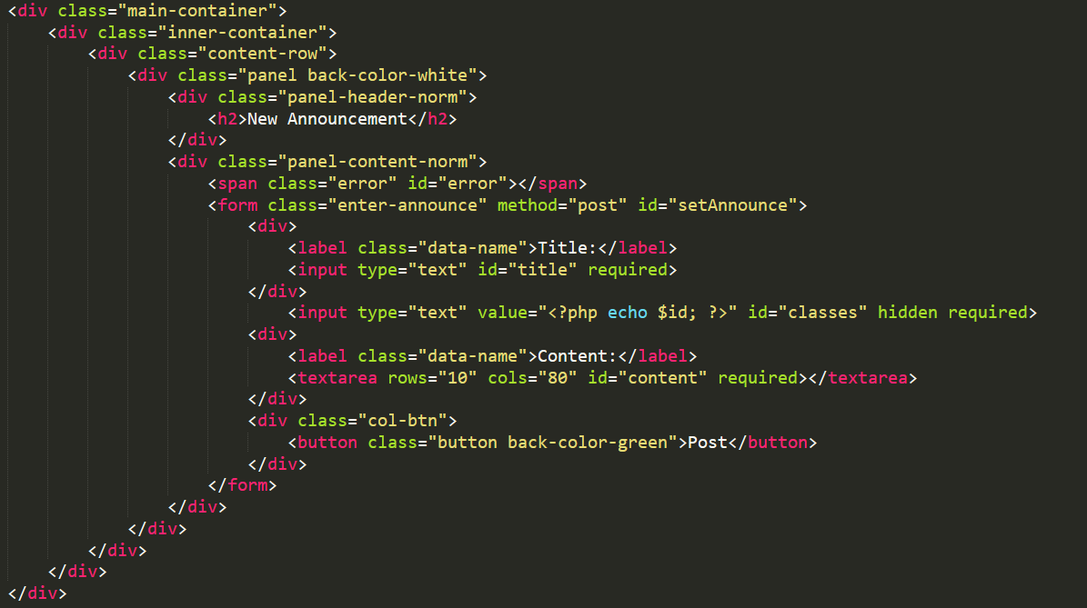

**Upload assignment:** Teacher can assign assignment to students.

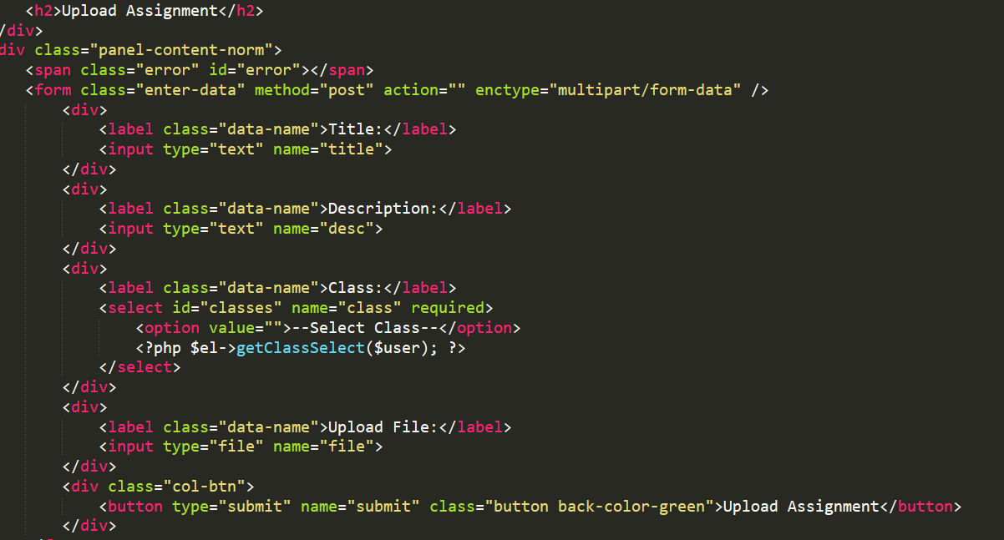

**Create quiz:** Teacher can assign quiz to students **.**

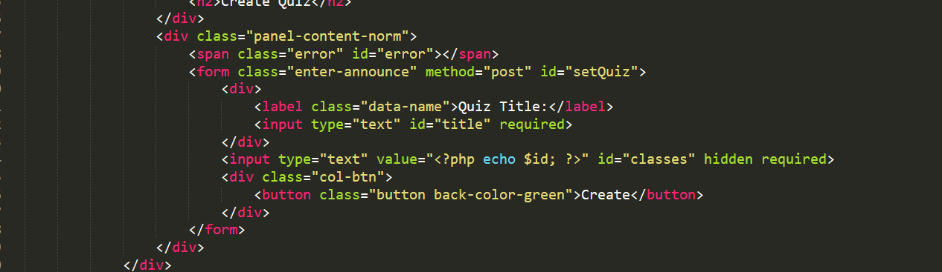

**Add student:** Teacher can add registered students to their class.

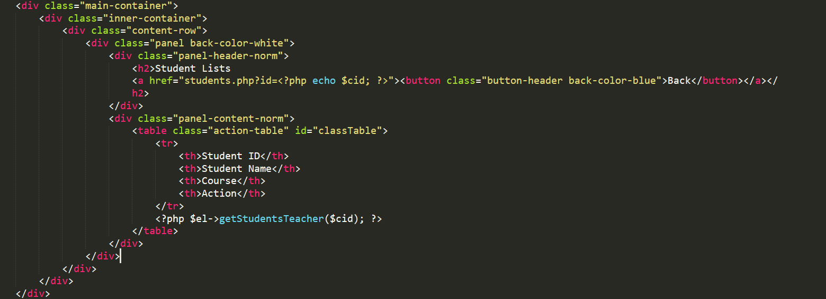

**Student module**

**Preview announcements:** Student can view the assignments posted by admin and teachers.

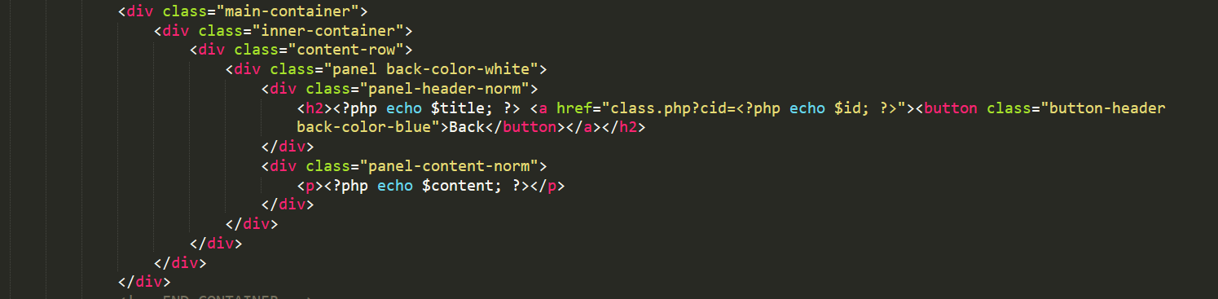

**Download assignment:** Student can download the assignment assigned by teacher.

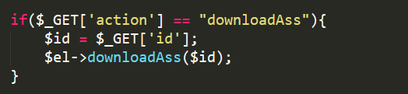

**Answer quiz:** student can answer quiz provided by teachers.

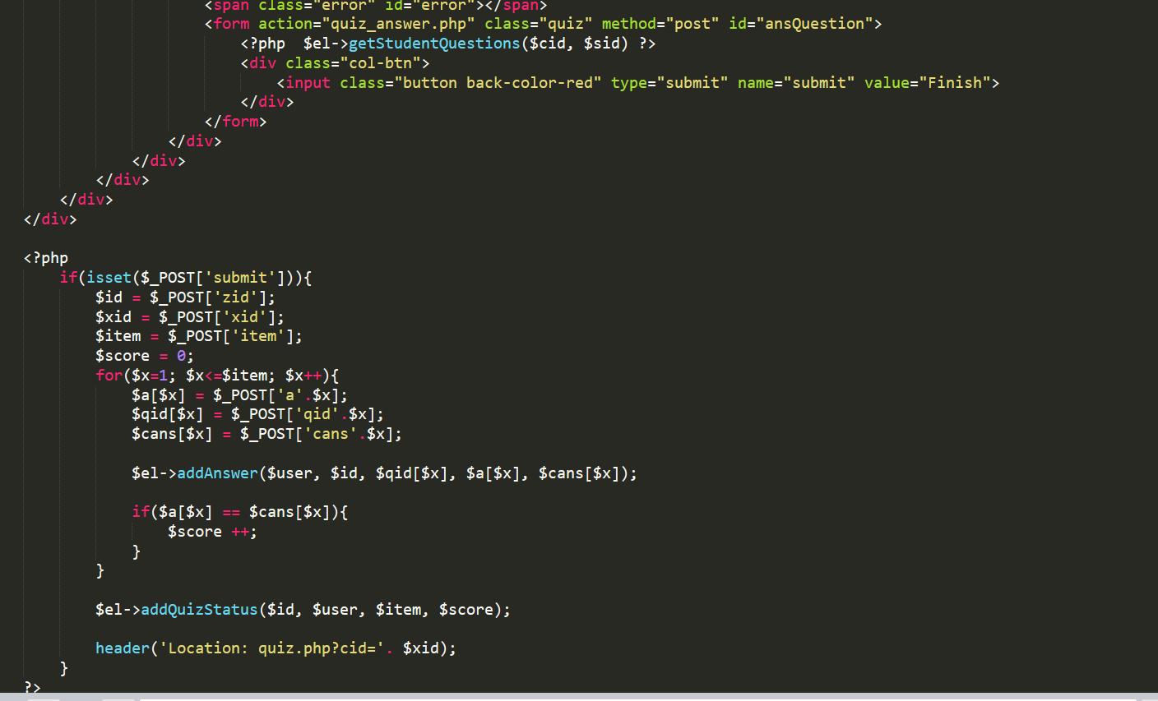

**View grade:** Students can check their grade for quiz they answered.

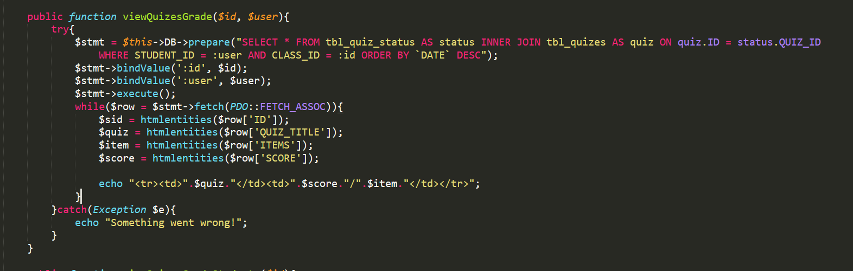

**View classmates:** students can see the list of their classmates in class.

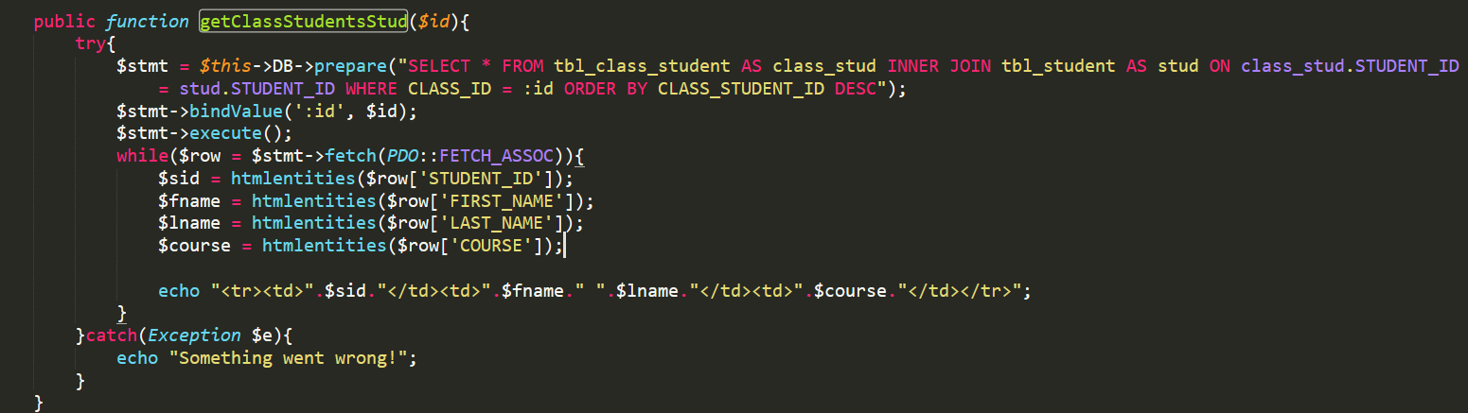

**CHAPTER 6**

**TESTING**

Software testing is an investigation conducted to provide stakeholders with information about the quality of the product or service under test. Software testing can also provide an objective, independent view of the software to allow the business to appreciate and understand the risks of software implementation. Test techniques include, but are not limited to, the process of executing a program or application with the intent of finding software bugs (errors or other defects).

**Block Box Testing**

Black-box testing tests functional and non-functional characteristics of the software without referring to the internal code of the software. It uses external descriptions of the software like SRS (Software Requirements Specification), Software Design Documents to derive the test cases. The validation (Project design and play), verification (Accessing application in multiple system throughout the organization), and general usability testing‘s (User interface, Bug free and faster access).

**White Box Testing**

The proposed application contains various different modules and integrated successfully. All independent paths within a module, logical decisions, loops at their boundaries and within their operational bounds and Database internal data structures and validations are working as per the client requirements.

**6.1 UNIT TESTING**

Unit testing refers to tests that verify the functionality of a specific section of code, usually at the function level. In an object-oriented environment, this is usually at the class level, and the minimal unit tests include the constructors and destructors.

These types of tests are usually written by developers as they work on code (white-box style), to ensure that the specific function is working as expected. One function might have multiple tests, to catch corner cases or other branches in the code. Unit testing alone cannot verify the functionality of a piece of software, but rather is used to ensure that the building blocks of the software work independently from each other.

Unit testing is a software development process that involves a synchronized application of a broad spectrum of defect prevention and detection strategies in order to reduce software development risks, time, and costs. It is performed by the software developer or engineer during the construction phase of the software development lifecycle. Unit testing aims to eliminate construction errors before code is promoted to additional testing; this strategy is intended to increase the quality of the resulting software as well as the efficiency of the overall development process.

**6.2 INTEGRATION TESTING**

Integration testing is any type of software testing that seeks to verify the interfaces between components against a software design. Software components may be integrated in an iterative way or all together ("big bang"). Normally the former is considered a better practice since it allows interface issues to be located more quickly and fixed.

Integration testing works to expose defects in the interfaces and interaction between integrated components (modules). Progressively larger groups of tested software components corresponding to elements of the architectural design are integrated and tested until the software works as a system.

**6.3 SYSTEM TESTING**

System Testing is a level of the software testing where a complete and integrated software is tested. The purpose of this test is to evaluate the system’s compliance with the specified requirements. The application is run to check if all the modules (functions) can be executed concurrently, if each return correct results of the operations performed by them, and if the data and index files are left in consistent states by each module.

|  |  |  |  |  |  |
| --- | --- | --- | --- | --- | --- |
| **Case** | **Description** | **Input Data** | **Expected output** | **Actual** | **Status** |
| **_id** | **Output** |
| 1. | Enter the | Valid | Registered | Registered | Pass |
| information | UserId and |
| for | Password |
| login |  |
| 2 | Enter | Enter the wrong | Invalid username and | Invalid username and | Pass |
| information | Password 2nd time | Password | Password |
| for |  |  |  |
| login |  |  |  |

Table 6.1 unit test cases for login details

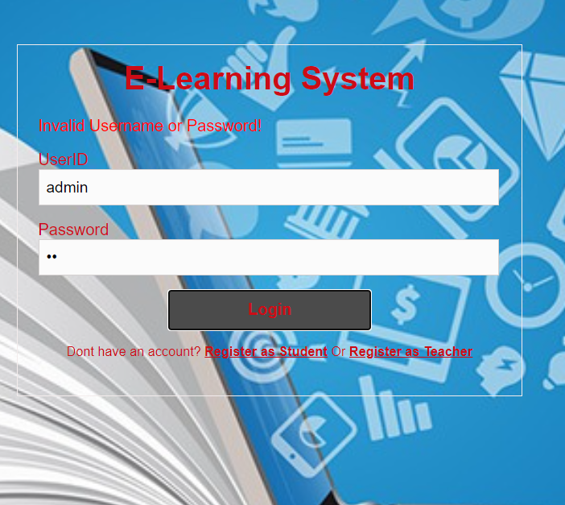

Fig 6.1 test case2 for invalid userid and password

|  |  |  |  |  |  |
| --- | --- | --- | --- | --- | --- |
| **Case** | **Description** | **Input Data** | **Expected output** | **Actual** | **Status** |
| **_id** | **Output** |
| 3 | Enter the | Valid | Registered | Registered | Pass |
| information | Userid and |
| for | Password |
| registration |  |
| 4 | Enter information for registration. | Password and confirm password not matched | Password not match | Password not match | Pass |
|  |  |  |  |
|  |  |  |  |
|  |  |  |  |
|  |  |  |  |  |  |

Table 6.2 unit test cases for registration details.

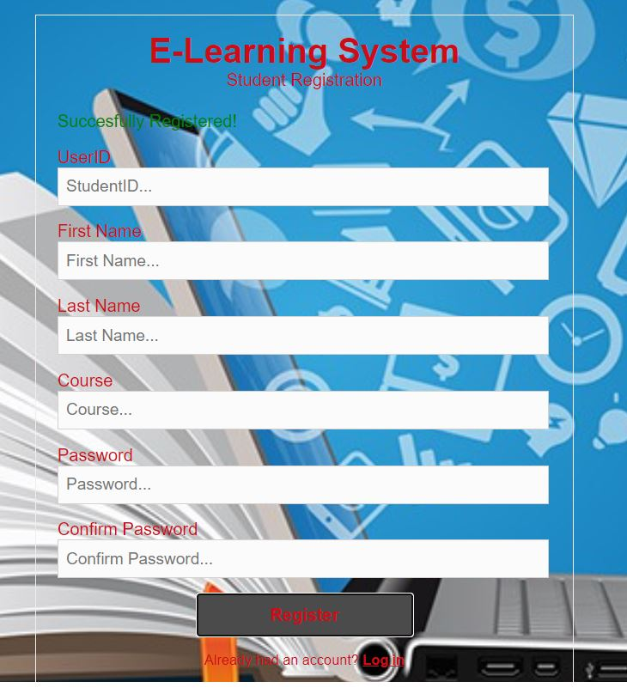

Fig 6.2 test case 3

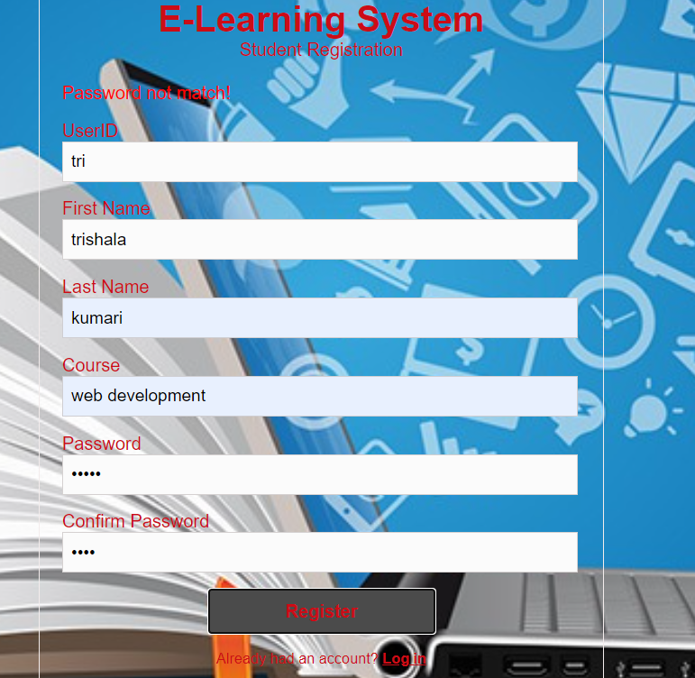

Fig 6.3 testcase 4

Fig 6.3 test cases for unique user

|  |  |  |  |  |  |
| --- | --- | --- | --- | --- | --- |
| **Case** | **Description** | **Input Data** | **Expected output** | **Actual** | **Status** |
| **_id** | **Output** |
| 5 | Enter Unique user id for registration | Enter unique user id | Registered | Registered | Pass |
|  |  |
|  |  |
|  |  |
| 6 |  | Enter same userid | Student already registered | Student already registered | Pass |
| Enter same user id for registration |  |  |  |
|  |  |  |  |
|  |  |  |  |

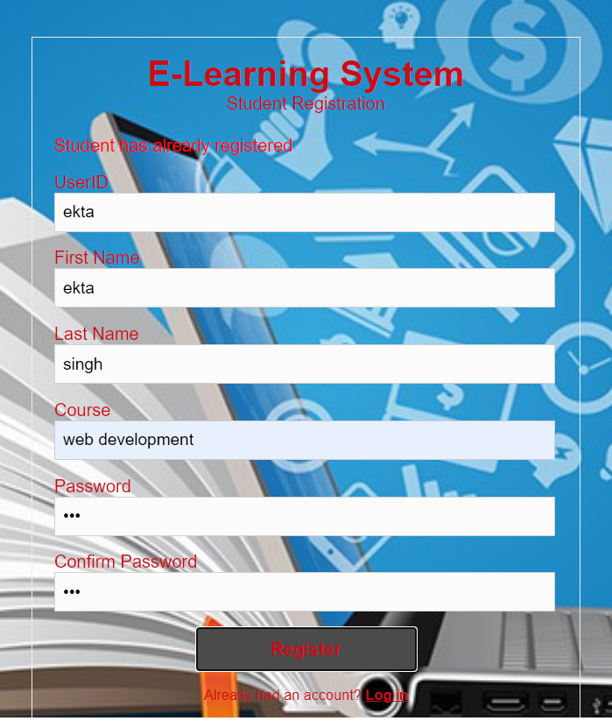

Fig 6.4 test case 6

Table 6.4 test cases for unique subject

|  |  |  |  |  |  |
| --- | --- | --- | --- | --- | --- |
| **Case** | **Description** | **Input Data** | **Expected output** | **Actual** | **Status** |
| **_id** | **Output** |
| 1. | Enter details for creating new subject | Enter details required | created | created | Pass |
|  |  |
|  |  |
|  |  |
| 2 |  | Enter same details | Subject has already created | Subject has already created | Pass |
| Enter details for creating new subject |  |  |  |
|  |  |  |  |
|  |  |  |  |

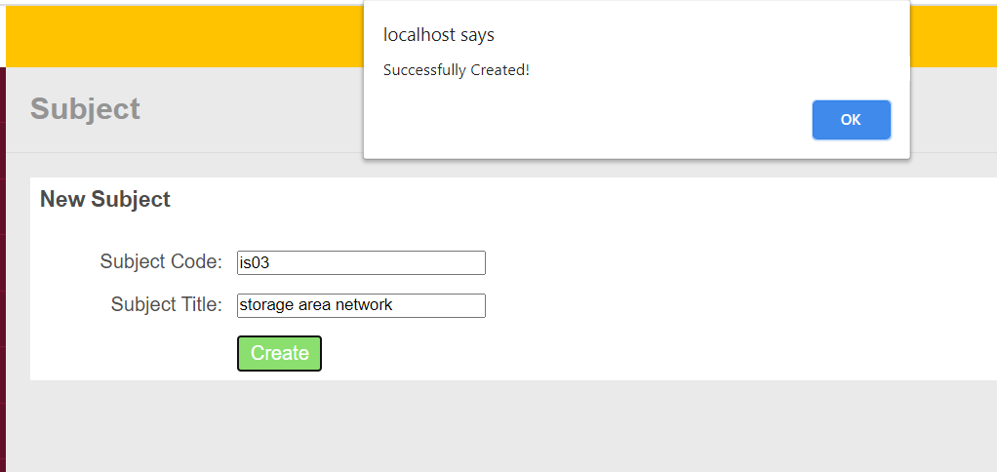

Fig 6.5 test case7

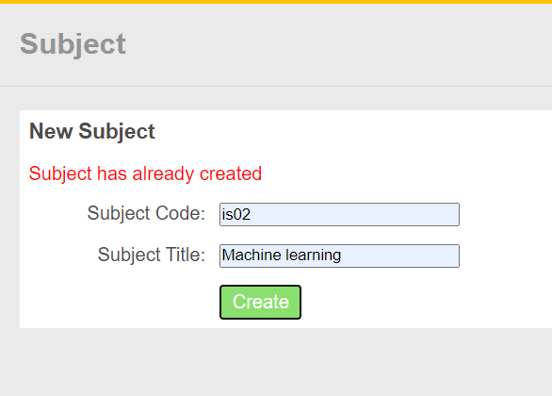

Fig 6.6 test case 8

**CHAPTER 7**

**SNAPSHOTS AND RESULT**



Fig 7.1 Home page

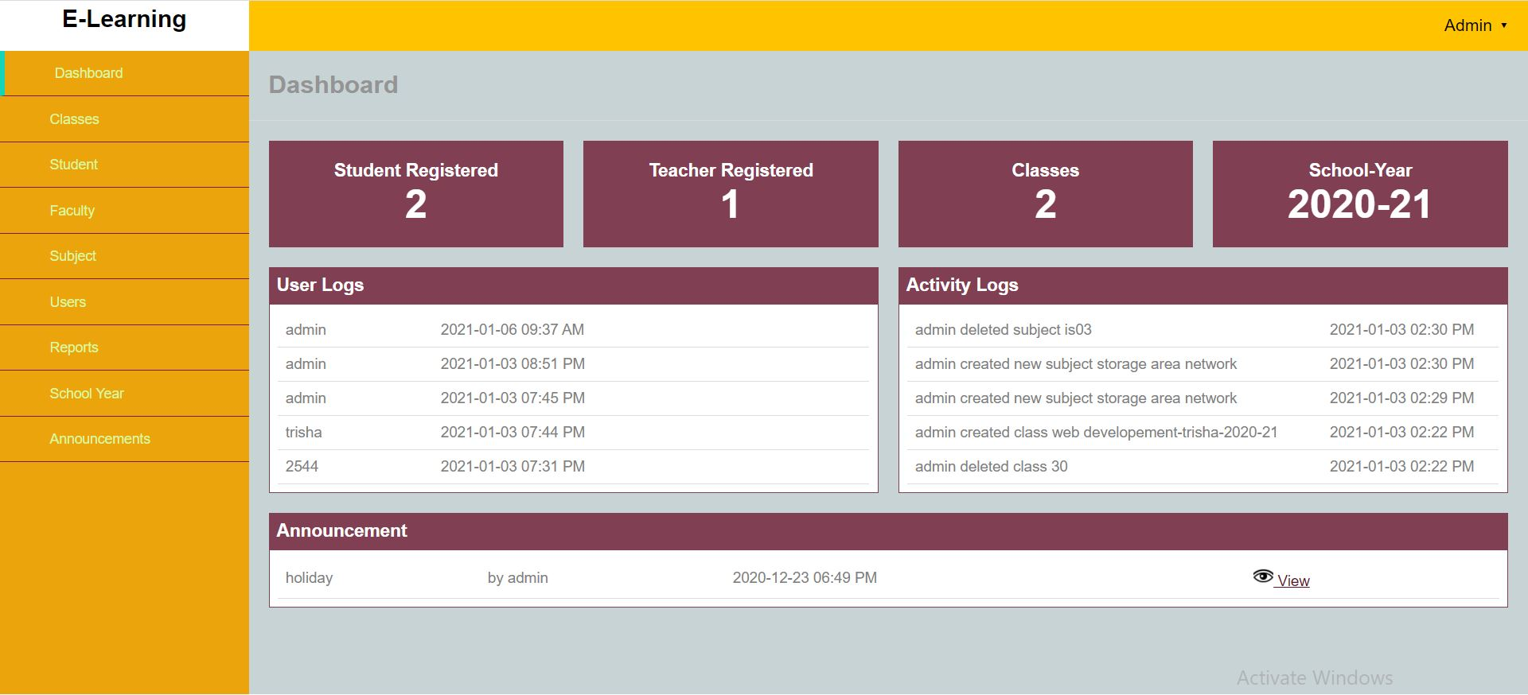

Fig 7.2 Admin’s Dashboard

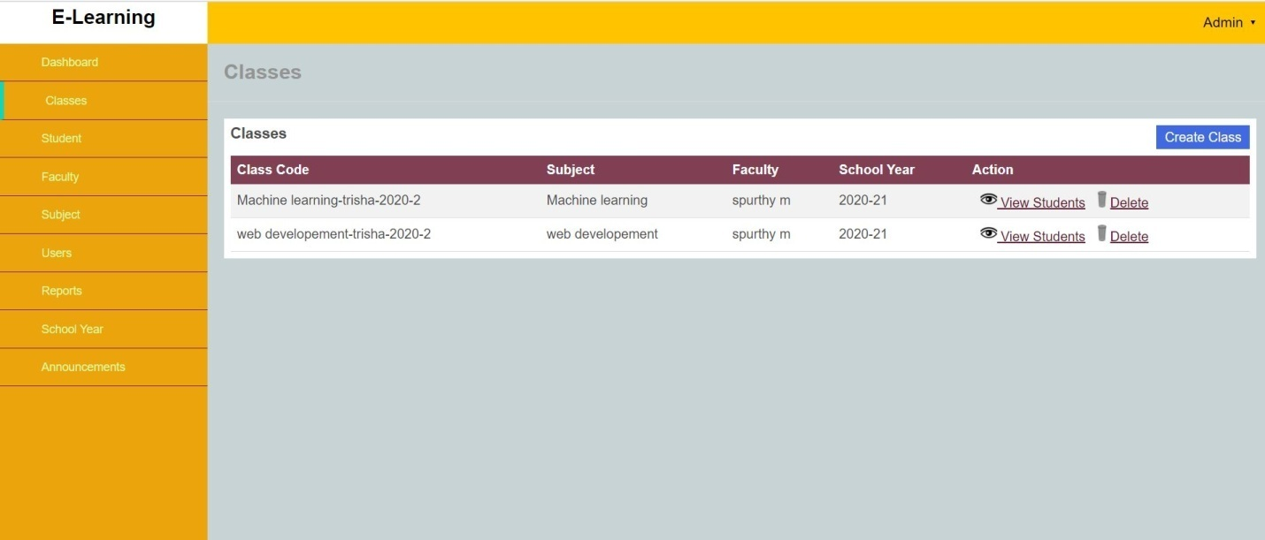

Fig 7.3 registered class

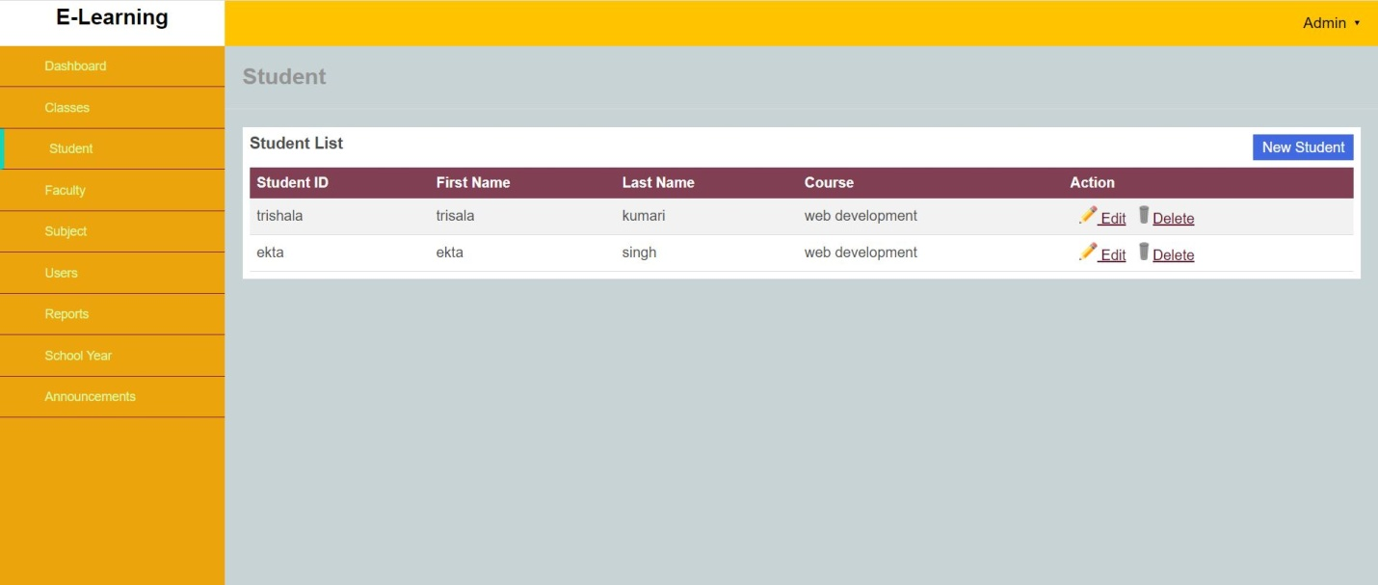Fig 7.4 Registered students

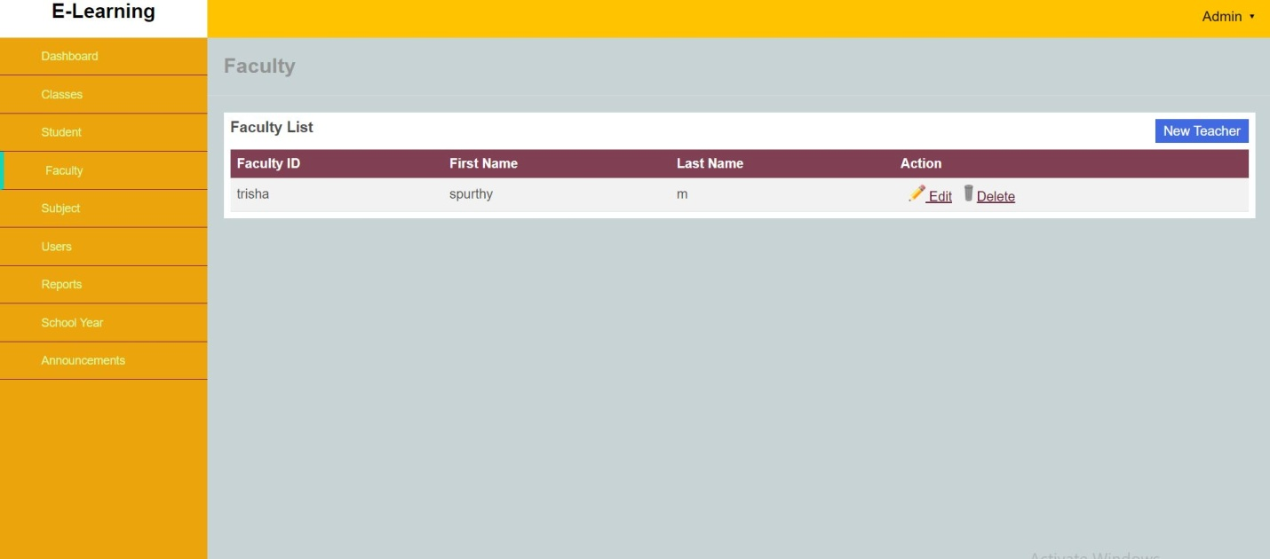

Fig 7.5 Registered teachers

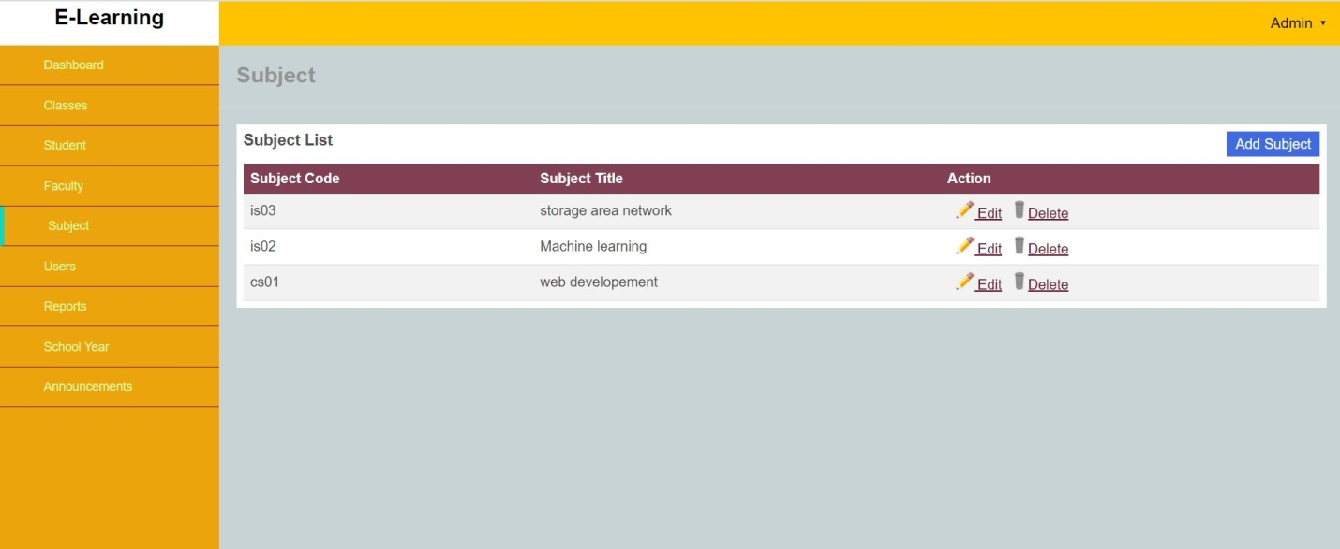

Fig 7.6 Registered subjects

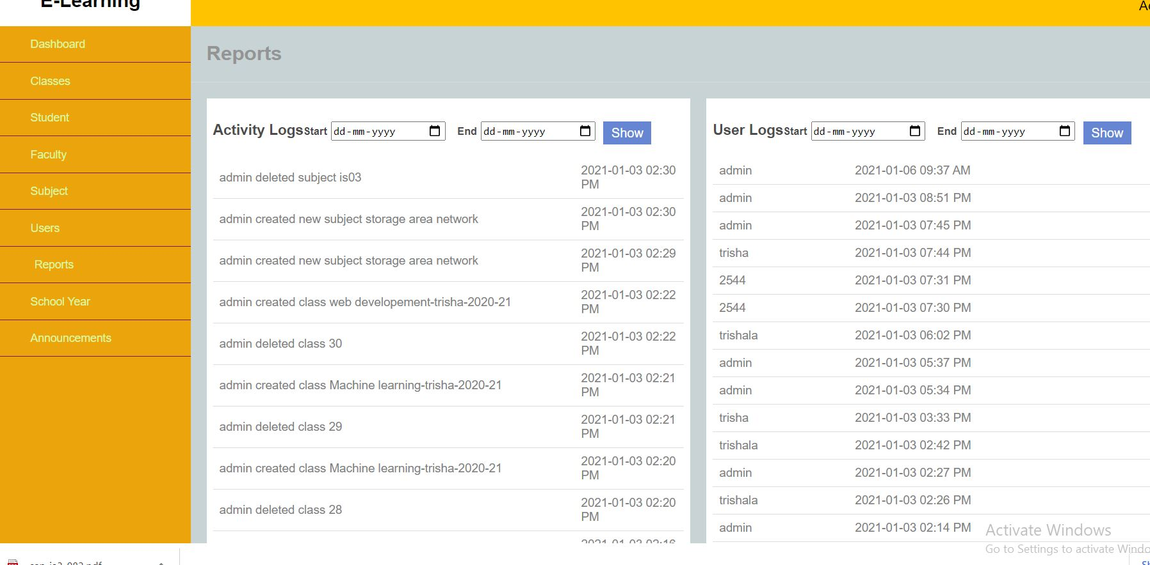

Fig 7.7 Reports

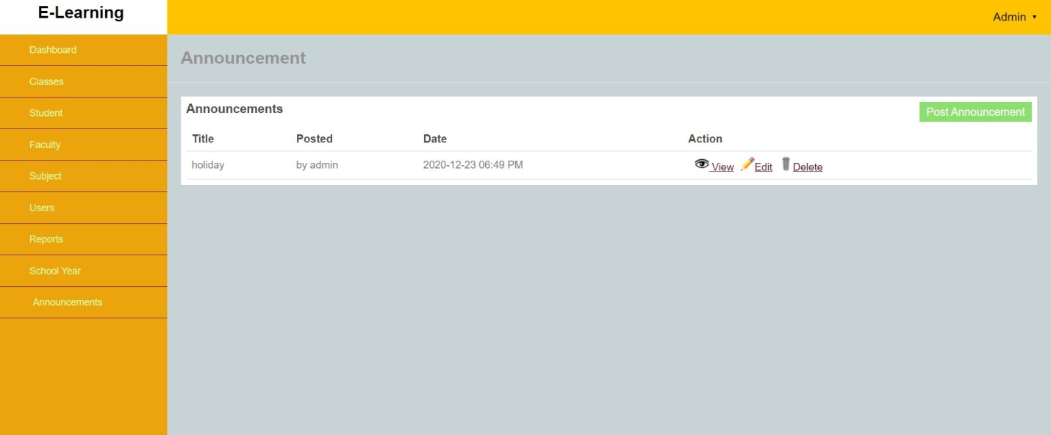

Fig 7.8 Announcements

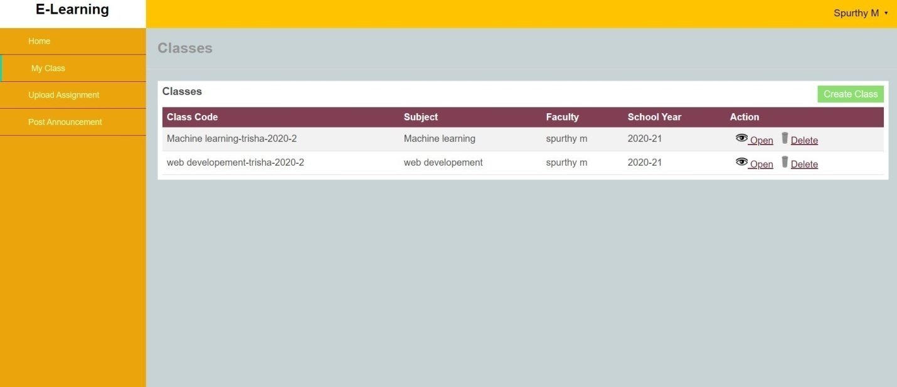

Fig 7.9 classes of faculty

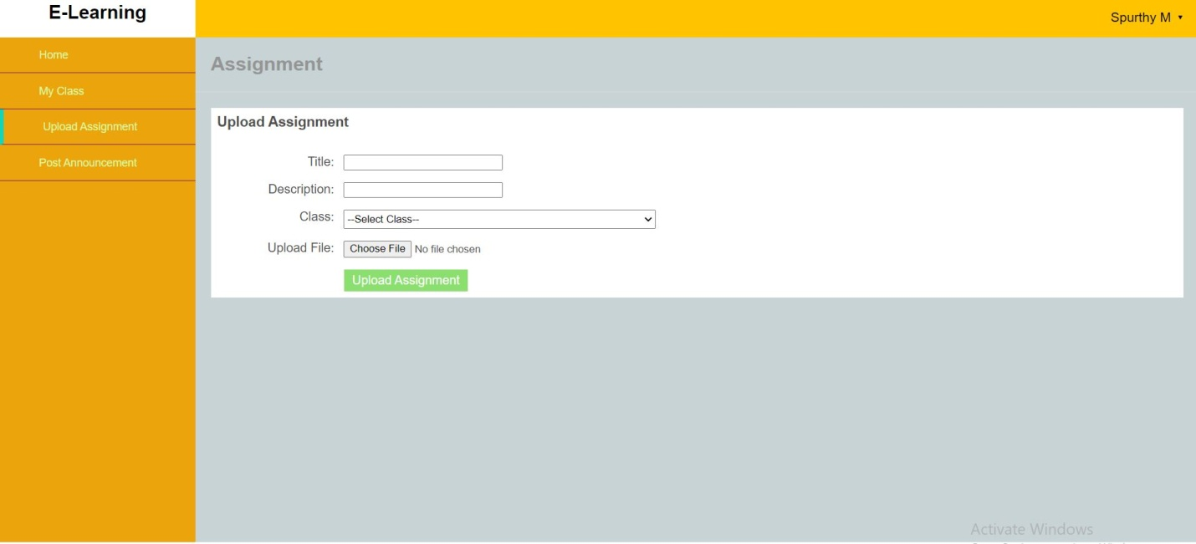

Fig 7.10 upload assignments

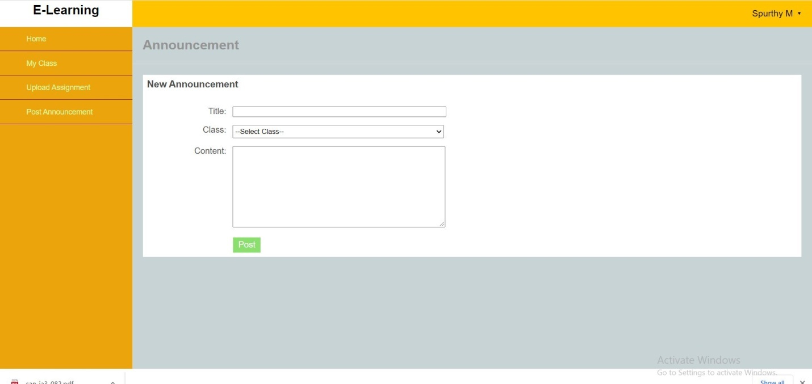

Fig 7.11 post announcement

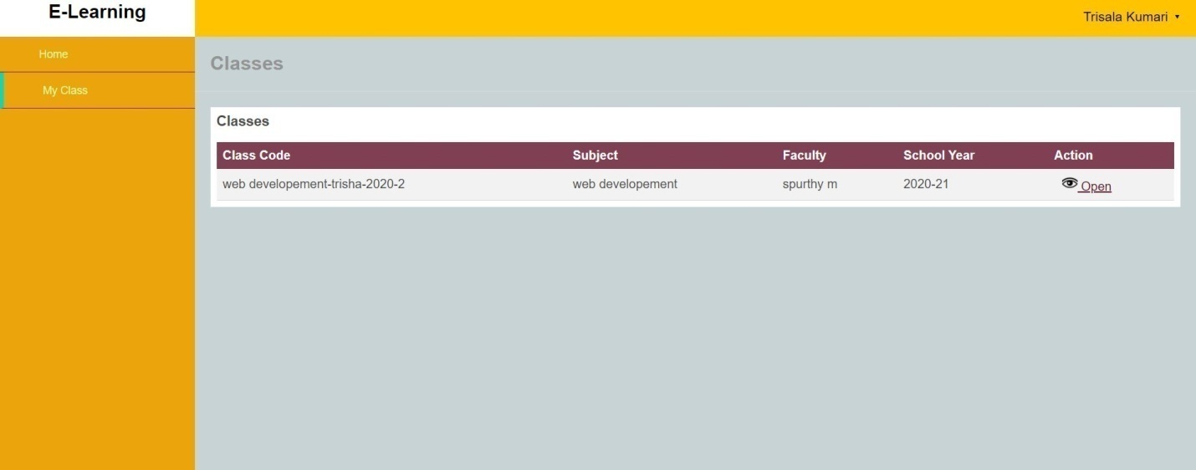

Fig 7.12 class detail of student

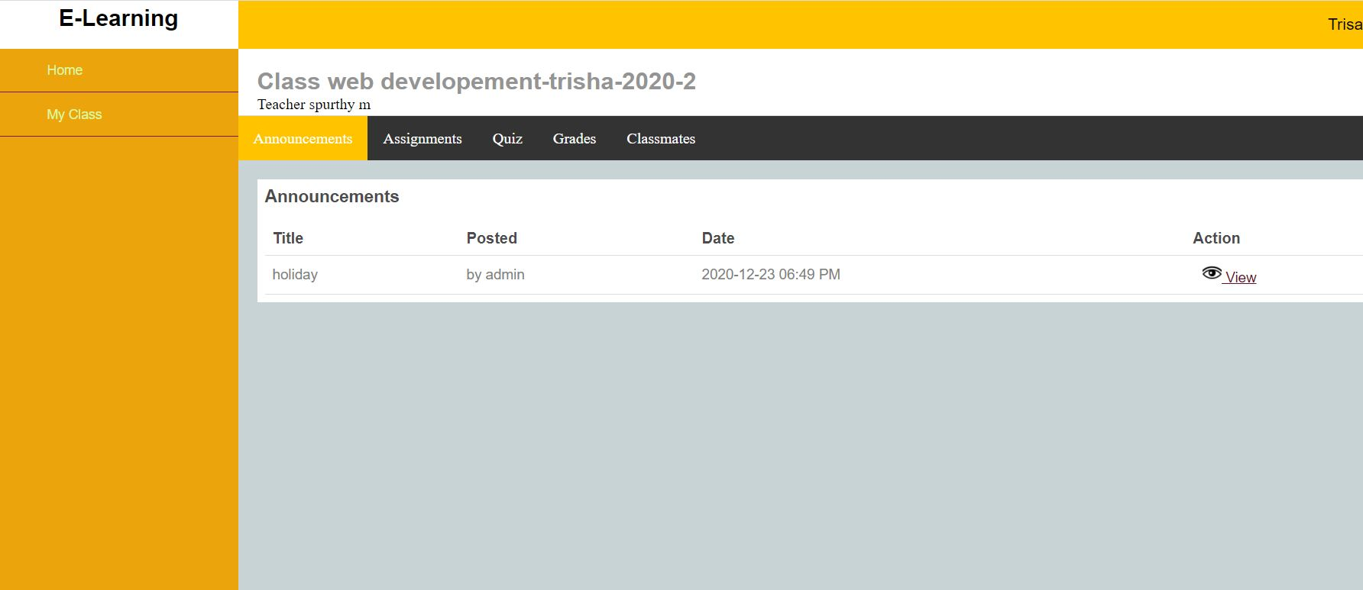

Fig 7.13 announcement preview

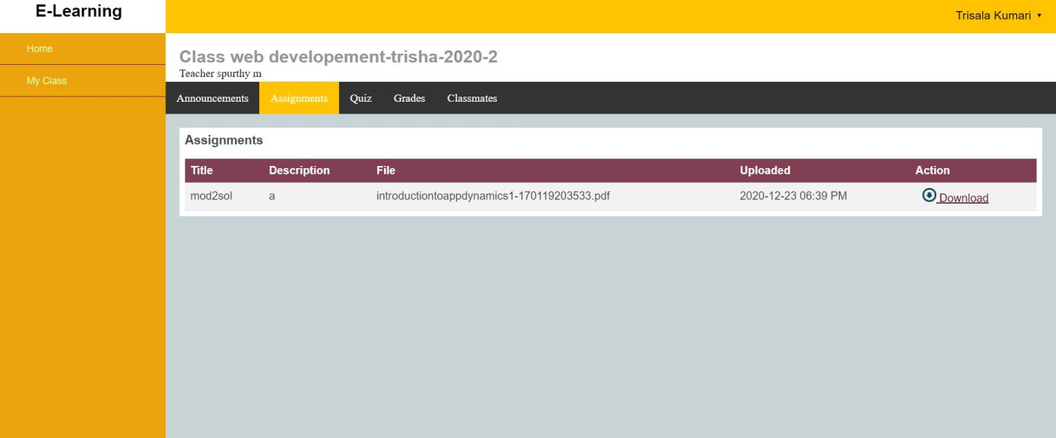

Fig 7.14 assignment preview

**CHAPTER 8**

**CONCLUSION AND FUTURE ENHANCEMENT**

E-Learning is learning utilizing electronic technologies to access educational curriculum outside of a traditional classroom. There are many terms used to describe learning that is delivered online, via the internet, ranging from Distance Education, to computerized electronic learning, online learning, internet learning and many others. We define e-Learning as courses that are specifically delivered via the internet to somewhere other than the classroom where the professor is teaching. Student and teachers communicate with each other effectively within a same platform.

The future enhancement of this system is that it can be made interactive we can also communicate with our teachers, professors or other students in our class in real time. Lessions can be delivered live, where we can “electronically” raise our hand and interact in real time and sometimes it is a lecture that has been pre recorded. There is always a teacher or professor interacting /communicating with us and grading your participation, our assignments and your tests

**REFERENCES**

1. <https://www.w3schools.com/php/>
2. <https://www.tutorialspoint.com/php/>
3. <https://www.coursera.com/html-css-javascriptl-tutorial/>
4. <http://www.freewebmasterhelp.com/tutorials/phpmysql>
5. <https://www.geeksforgeeks.org/php-mysql-select-query/>
6. <https://www.tutorialrepublic.com/php-tutorial/php-mysql-select-query.php>